|  |  |
| --- | --- |
| Team ID | PNT2022TMID50137 |
| Project Name | Smart fashion recommender application |
| Team members | Gokul S  Jesu Denison K  John Prakash I  John Stephen J |

Send grid Open Page:



Sendgrid login Page:

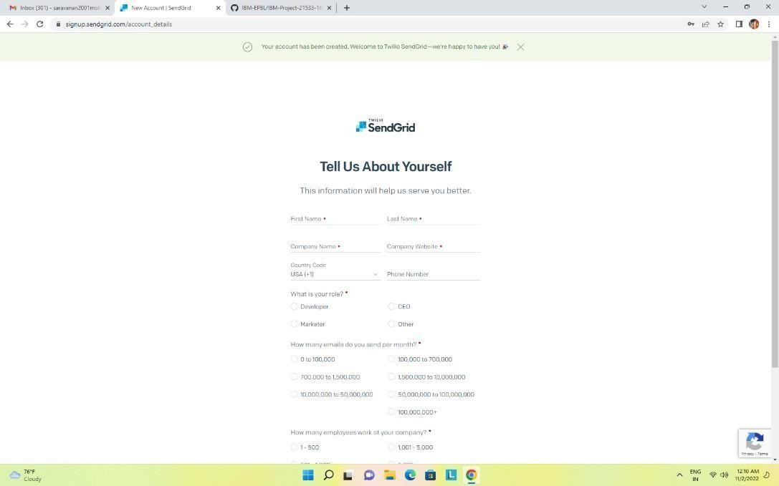

Send grid successfully created:

